2023 KY LEGISLATIVE WEBSITE LINKS &
KENTUCKY SOCIAL WORK ASSOCIATIONS!
Kentucky Proud. Social workers and students collaborating, networking, and empowering our profession across Kentucky. Our voices. Our vision. Be the change? We are the change!
We hope you enjoy this additional mini-Tool-Kit that will be updated each year in time to celebrate KY Social Work Lobby Day. As social workers and social work students, it is critical to become familiar with our legislative process in the classroom and in our communities and how it impacts Kentucky citizens. Please take some time to review each link so you can become informed and active in Kentucky policy and advocacy. We have made it easy to access the many different sections of the website simply by clicking ‘open hyperlink’ to explore everything you need to know about the legislative process.
We have also included links and information about social work associations in Kentucky, as well as links to BSW, ASWB. and CSWE. Please check out the KSWAN YouTube channel: https://www.youtube.com/@kentuckysocialworkadvocacy3808 because this is where you can find all of our taped virtual lobby day programs during the pandemic, as well as new additions on 2/22/23, March Social Work Month, and across 2023. Gratitude to Carrie Cole, MSSW, for creating this channel and recording the videos. KY Social Work Lobby Day is the perfect example of social workers and students working together to keep us engaged, educated, and empowered 365/24.
Please register for 2/22/23 Social Work Lobby Day/Rally in the Rotunda at 1pm: https://forms.gle/8pagZJVQ9pxexzHr6

SOCIAL WORK IS POLITICAL!
Let’s begin by finding your KY legislators:
https://apps.legislature.ky.gov/findyourlegislator/findyourlegislator.html
My Representative (House) is: ________________________________________
My Senator is: ____________________________________________

How do I leave a message for Kentucky legislators?
CALL 1-800-372-7181

MONDAY THROUGH FRIDAY FROM 8:00AM-4:30PM/EST
** DURING THE LEGISLATIVE SESSION THE HOURS ARE FROM 7:00AM-11:00PM MONDAY THROUGH THURSDAY AND 7:00AM-6:OOPM ON FRIDAY.
YOU CAN LEAVE A MESSAGE OF SUPPORT OR OPPOSITION FOR BILLS AND CAN CALL EVERY DAY. WE HAVE ADDED A WORKSHEET FOR YOU TO USE TO KEEP TRACK OF THE BILLS YOU WANT TO SUPPORT, OR NOT. BE SURE TO KNOW: IF IT IS A SENATE BILL: SB OR A HOUSE BILL: HB & THE NUMBER OF THE BILL.
YOU CAN HAVE YOUR MESSAGE SHARED WITH YOUR REPRESENTATIVE AND SENATOR, THE COMMITTEE SPONSORING THE BILL, OR THE ENTIRE GENERAL ASSEMBLY. YOU CAN CALL EVERY DAY WITH THE SAME MESSAGE, .SO PLEASE KEEP TRACK OF THE BILLS IN THE EVENT THEY CHANGE NUMBERS
**PLEASE KEEP YOUR MESSAGE SHORT AS EVERY WORD IS RECORDED AS SPOKEN. NO FOUL LANGUAGE PLEASE. PLEASE THANK THE PERSON WHO TAKES YOUR MESSAGE BECAUSE THEY TAKE THOUSANDS OF MESSAGES DAILY!

LRC provides several toll-free Numbers.
Legislative Message Line | 1-800-372-7181
Bill Status Line | 1-866-840-2835
Kentucky Relay Service | 711
Calendar (Meetings) Line | 1-800-633-9650
En Español | 1-866-840-6574
Solamente durante la sesión legislativa
*Toll-free numbers are operational only in Kentucky

LEGISLATIVE RESEARCH COMMISSION:
Main Phone: 502-564-8100
Address: 700 Capital Ave., Frankfort, KY 40601
PLEASE CLICK ON EACH SECTION TO BE DIRECTED TO THE SPECIFIC INFORMATION ON THE LEGISLATIVE WEBSITE. IF YOU HAVE TROUBLE ACCESSING THESE LINKS, PLEASE REFER TO:
https://legislature.ky.gov/Pages/index.aspx

Bills –
Kentucky Law
Kentucky Revised Statutes - KRS
Kentucky Administrative Regulations - KAR
Kar FAQs
Registers
Emergency Regulations by Number
Last Effective Dates, Expirations, and Certifications·

Legislator –
Legislative Calendar
Schedules & Calendars
Search
Committees
House Standing Committees
Interim Joint Committees
Special Committees
Senate Standing Committees
Caucuses
Statutory Committees
Public Services

**When you are done checking out these important links, don’t forget to sign up for Bill Watch:
https://www.kentucky.gov/services/pages/billwatch.aspx

MY LEGISLATIVE WORKSHEET
WHAT BILLS I DO and DO NOT SUPPORT:
YES: NO:
_____________________ ____________________
____________________________ ___________________________
____________________________ ____________________________
____________________________ ____________________________
____________________________ ____________________________
____________________________ ____________________________
____________________________ ____________________________
____________________________ ____________________________
____________________________ ____________________________
____________________________ _____________________________
NOTES:

​​​​​​​​​​ KENTUCKY SOCIAL WORK ASSOCIATIONS
Kentucky Social Work Lobby Day is a collaboration between the below social work associations and groups who work together to engage, educate, and empower social workers and students through advocacy, networking, and mentoring. We strive to support each other and our commitment to make a better Kentucky for everyone.

https://www.kscsw.org/

Kentucky Society for Clinical Social Work - HOME - KSCSW
The Kentucky Society for Clinical Social Work (KSCSW) is committed to promoting a strong professional image for Kentucky clinical social workers, educating its members about legislation that affects their practices, and upholding ethical excellence.
www.kscsw.org

https://www.kassw.org/

Home | KASSW
About Us. KASSW is committed to improving the quality of life and education for Kentucky's children by enhancing the professional development of school social workers.
www.kasswky.com

NASW-KY Kentucky Chapter: https://naswky.socialworkers.org/

www.socialworkers.org  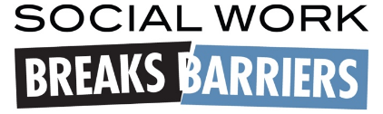  Get a free Social Work Month Toolkit Here:  www.socialworkers.org/News/Social-Work-Month | National Association of Social Workers - NASW Home  Founded in 1955, the National Association of Social Workers (NASW) is the largest membership organization of professional social workers in the world, with more than 120,000 members. NASW works to enhance the professional growth and development of its members, to create and maintain professional standards, and to advance sound social policies.  www.socialworkers.org

National Association of Black Social Workers (NABSW)
Join the National Association of Black Social Workers . The National Association of Black Social Workers, Inc., comprised of people of African ancestry, is committed to enhancing the quality of life and empowering people of African ancestry through advocacy, human services delivery, and research.
www.nabsw.org

South Central Chapter: Monica.hines@wku.edu or Torchia.rogers@gmail.com
Phone number 270-745-2523
UK Chapter: @ABSW_UK (Twitter and Instagram)
kywildcatsabsw@nabsw.org

Social Work Anti-racist Coalition of Kentucky
https://www.facebook.com/SWARCKentucky
https://www.swarck.com/demands

KASWE https://www.kaswe.org/ The members of KASWE strive to: Promote a better understanding and communication among social work educators, and between social work educators and social work
- practitioners, and between social work educators and students. Facilitate the coordination and linkages of social work education programs within the state of Kentucky.
- Advocate the professional interests of social work educators and of the social work profession.
- KASWE also supports the demands of the Social Work Anti-Racist Coalition of Kentucky.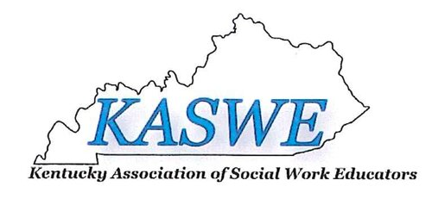

KSWAN
https://www.facebook.com/groups/3949197731781127
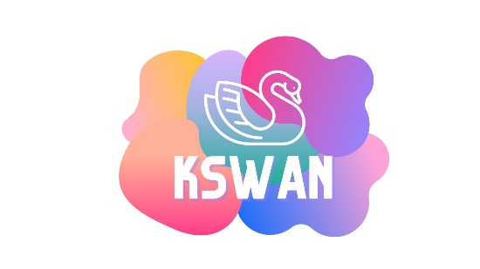 | Kentucky Social Work Advocacy Network (KSWAN)  Kentucky Social Work Advocacy Network (KSWAN) is a collaboration across all Kentucky Social Work associations and universities, comprised of all Kentucky Social Workers, both students and...  www.facebook.com

KENTUCKY BOARD OF SOCIAL WORK:
https://bsw.ky.gov/Pages/index.aspx

ASSOCIATION OF SOCIAL WORK BOARDS:
https://www.aswb.org/

COUNCIL ON SOCIAL WORK EDUCATION:
https://www.cswe.org/

ADVOCACY IS IMPORTANT TO SOCIAL WORK BECAUSE:

